Intake of

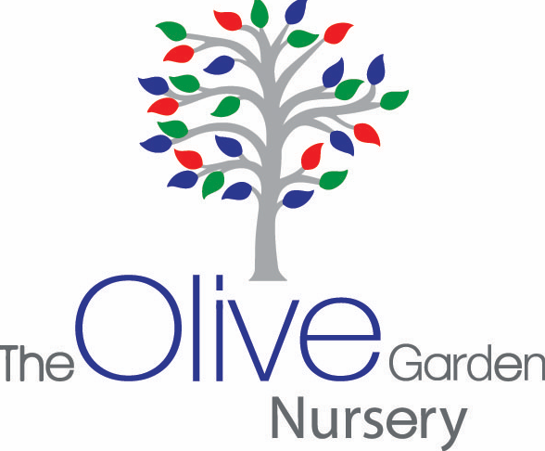

Request application for a nursery place 2/3 years old

Parents kindly complete the information about your child.
Note that this is only an initial Application and does not guarantee a Nursery place for your child.
Children are accepted on an age basis and not on a first come first serve basis.
As soon as your child is eligible for funding and we have a vacancy, the parent will be contacted by the Nursery.

Name of Child: …………………………………………
Date of Birth……………………………………

Address: ……………………………………………………………………………………………………………..

Contact no 1 ………………………………………………………………………………………..

Contact no 2…………………………………………………………………………………………

Email Address ……………………………………………………………………………………………………….

Is your child eligible for the 2 year old funding ? ………………………………………………

Would you be interested in the 30 hour funding?..................................................

Is the parent a committee member of Ar-Rahman Masjid? …………………………………………..

If yes, please state name of member

………………………………………………………………………………………………………………

Is the child a “looked after child” by Local Authority?.........
Does the child have additional needs and is on a “Early Help’…………………..

Has the child above previously had a sibling attending The Olive Garden Nursery in the last 3 years?................

If yes, name of child and year attended

.............................................................................. Year……………………..

Please specify which session you would prefer Morning □ Afternoon □

Date:...................................Signed by staff member……………………………………………

Please notify the Nursery if there are any changes in these details from the time this Application Form has been sent to the Nursery
NOTE: The cut off point for admissions for the following September will be before the February half term.

