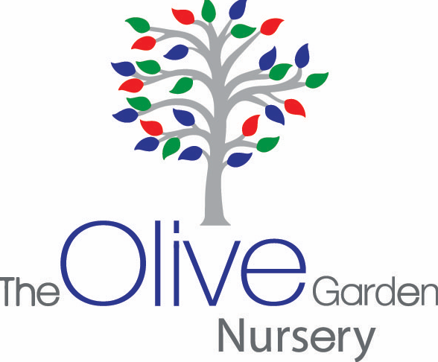
Intake of

Waiting list form for 3 year old

Name of Child: …………………………………………

Date of Birth: ………………………………………..

Address: ……………………………………………………………………………………………………………..

Contact no 1 ………………………………………………………………………………………..

Contact no 2…………………………………………………………………………………………

We offer 15 hours free for all parents. Please specify which session you would prefer
5 Mornings □ OR 5 Afternoons □

If BOTH parents are working you will be eligible for 30 hours funding. Please tick if you require this - 30 hours □

Please use the following link to see if you are eligible. https://www.childcarechoices.gov.uk/

Is the parent a committee member of Ar-Rahman Masjid? …………………………………………..

If yes, please state name of member

………………………………………………………………………………………………………………

Does the child have additional needs? ………………………………………………………………..

Is the child a “looked after child” by Local Authority? ……………………………

Date:...................................

NOTE: The cut off point for admissions for the following September will be before the February half term.

